
St. Mary’s FIRST NATION

SUMMER Career
Education
Program

Student Workbook
This workbook belongs to:

Name: _______________________________________________________________________
Phone Number: _______________________________________________________________
If found please call the above number to return to the owner. Thank you!
The St. Mary’s First Nation Summer Career Education Program

is hosted by

St. Mary’s First Nation Education Department

Thanks to all those for their continued support.

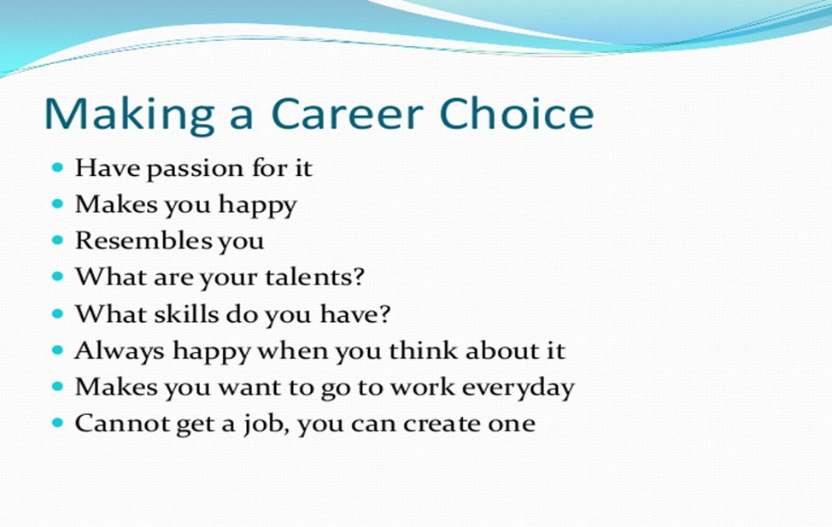

Welcome!

Thank you for your participation in the SMFN Summer Career Program. For everyone involved in the program, there are some program regulations that we request everyone follows.

- Out of respect for the guest speakers that take the time to come and share their professional knowledge with you, please put your cell phones away, pay attention, participate in any hands-on experiences that are available, and ask as many questions that you need. Remember, if you have a question, there are likely other people in the group that have the exact same question.
- Your career placement position – it is permanent for the duration of the program.
- There will be absolutely no tolerance for drugs or alcohol during classroom training or during your work hours. This will result in immediate dismissal from the program.
- Cell phones MUST be put away.
- You will be expected to work the hours that the employer schedules you for
- There will be absolutely no tolerance or disrespect towards any persons – fellow participant, employer, coordinator, guest speakers, and admin staff, involved in the Summer Career Program at any time during the program.
- Students will be responsible for transportation to and from their career placement
- You are paid a week behind.
- Cheques will be able to be picked up at the Education Department on Thursdays.
- There will be no tolerance of absenteeism during the program.
- You do not get paid for time missed.
- To challenge for credit, you must participate in the presentation portion of the program.
- Students challenging for credit, the workbook MUST be completed in full. For all other students, the workbook must be completed in regards to the workshops you attended, your time sheets, your career placement, the work environment, career success, and the final student evaluation filled out and signed by your mentor.

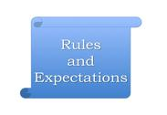

What is the SMFN Summer Career Education Program?

- The SMFN Summer Career Education Program is a combination of in class job readiness and skills training workshops and on the job work placements designed to expose students to the working world and experience what it would be like to work in the field of their potential career goals.

- The program starts with a one-week job readiness skills training designed to provide students with a better understanding of the work environment and workplace expectations.

- During the students’ career placements the students will have an on-the-job mentor and will be monitored by the Career Program Coordinator to ensure they are getting the maximum benefits.

- The SMFN Summer Career Education Program finishes with one week of further in-class skills training workshops for those challenging for credits. The students will be given some time to prepare their projects for a presentation for credit challenge.

- Grade 10, 11 and 12 Leo Hayes students who have successfully completed the program may apply for 2 credits towards graduation provided they have not already done so.

Question: How do you think that this program will benefit you determining your career path?
Answer: _____________________________________________________________________________________________________________________________________________________________________________________________________________________________________________________________________________________________________________________________________________________________________________________________________

Challenging for Credit
Students who intend to apply for credits towards graduation must make their intentions known by completing the application form with the Summer Career Coordinator at the beginning of the program. If you have previously challenged for credit, you may not do so again.

There are two phases that must be completed to be awarded the two credits. To challenge for credit, students must have successfully completed their work placement, the workbook, and the project. These will be presented to the Education Department in week 5 of the program. Points will be awarded based on the following:
Phase 1:
- Summer Career Education Program Student’s assessments points will be awarded in the following categories:
Overall Performance and Participation: 40 Points:
- 15 points: Evaluation of their behavior, participation and performance in class
- 5 points: Feedback from those delivering workshops
- 20 points: Evaluation of their behavior, participation and performance on the job
Student Workbook: 20 Points:
- 15 points: quality and content of the answers to the questions and the amount completed
- 5 points: neatness and legibility
Attendance: 20 Points:
- Students will lose .83 points for every day missed
Note: Unless for medical or emergency situations students are expected not to miss any time. Dependent on the circumstances, those that do may be removed from the program at the discretion of the Summer Career Program Coordinator.
Total possible points: 80
Phase 2:
- Challenge for Credit:
In order to challenge for credit students must achieve a minimum of 60 points out of the possible 80 points.
- The base mark that they have earned in the Career Education Program
- 20 additional marks can be earned via the delivery of a presentation highlighting their work experience, what they have gained from the program, and what they have discovered about themselves.
- The presentation will be delivered to a 2-3 person panel who will collectively evaluate and determine the final mark as well as the award of two credits.

Research Project/Presentation:
Overview:
The objective of your summer career placement is to gain a deeper understanding of your potential career choice(s) by having the opportunity to shadow and observe an employee/mentor working in your specific field of choice.
During the work placement, along with completing the various aspects of the workbook, you will be expected to conduct a project in which you will be required to thoroughly examine the nature of the work, job duties and responsibilities, training requirements, peer relations, workplace environment, job realities, terminology, etc. You will also need to conduct and incorporate into your presentation, an analysis of your particular strengths as well as limitations relevant to the career.
The research project and presentation incorporates the notion of improving work habits, human relations skills, and motivational factors. It also requires practicing determination, discipline and industriousness to complete and will help in broadening employment/career related vocabulary.
Each student will be required to present his/her findings to the Education Department during week 5. The debriefing week is multipurpose that provides the student with the opportunity to share and be recognized for their learning, as well participate in group discussions regarding work place realities. It also provides the career counselor the opportunity to assess their work analysis, assist them in confirming their specific career directions, prepare and focus on upcoming coursework, and discuss strategies for improving group, and individual, behavioral strengths and limitations.

As previously stated, in order to gain credit towards graduation, students will also do their presentation in front of a 2-3 person panel. In recognition of individuals learning styles, presentations may be in the form of a formal presentation, art, music, practical demonstrations, or any other creative combination. The presentation must convey the students’ knowledge of the job and demonstrate his/her fit to the position.

AWARDS

Presentations will be assessed and awards will be given at the closing banquet for:

- Best Demonstration of Job Knowledge – Presentation and ability to answer questions First Year Students

- Best Demonstration of Job Knowledge – Presentation and ability to answer questions Senior Students

- Best Overall Program Participation - All students



Tentative Schedule

Week 1: Job Readiness Skills Training & Workshops / First Aid & CPR Training

Monday  9am-4pm  June 29 | Tuesday  9am-4pm  June 30 | Thursday  9am-4pm  July 2 | Friday  9am-4pm  July 3
9:00-9:30  Summer Career Orientation  9:30 – 10:30  HR and Payroll discussion  10:30- 10:45Break  10:45-12:00  Job Readiness  Presentation  12:00-1:00 Lunch  1:00 – 2:15  Job Readiness  2:15-2:30 Break  2:30 – 4:00  Job Readiness | 9-930  Summer Career Overview Student questions  9:30- 10:30 Job Readiness  10:30-10:45 – Break  10:45- 12:00  Job Readiness  12:00-1:00 Lunch  1:00-2:15  Job Readiness  2:15-2:30 Break  2:30-4:00  Job Readiness  Workbooks | 9:00-12:00  First Aid & CPR  Breaks will be given at the instructor’s discretion  Lunch 12:00-1:00  1:00-4:00  First Aid & CPR  Breaks will be given at the instructor’s discretion  Grades 10, 11, & 12  Students not listed for First Aid will go to their job placements. | 9:00-12:00  First Aid & CPR  Breaks will be given at the instructor’s discretion  Lunch 12:00-1:00  1:00-4:00  First Aid & CPR  Breaks will be given at the instructor’s discretion  Grades 10, 11, & 12  Students not listed for First Aid will go to their job placements.

Weeks 2, 3, and 4

All students will be at their job placements. Your hours will be scheduled by the employer. You may also have to work evenings and / or weekends.

Week 5:
Presentations and Project for Credit Challenge

Monday  9am-4pm | Tuesday  9am-4pm | Wednesday  9am-4pm | Thursday  9am-4pm
9-9:30 Overview of the day  Discussion of presentations  10:15-10:30 Break  10:30-12:00 – Work on Presentations and Workbooks  12:00-1:00 Lunch  1-2:15  Work on Presentation  2:15- 2:30pm Break  2:30-4:00 | 9-9:30 Overview of Day  9:30 – 10:30 Workbooks and presentation Prep  10:30-10:45 Break  10:45- 11:30  Presentation and workbooks  12:00-1:00 Lunch  1:00-2:15  Work on Presentations  2:15- 2:30pm Break  2:30 – 4:00 Work on Presentation | 9:00-12:00  Presentations  Workbooks are due.  Breaks will be given at the instructor’s discretion  12:00-1:00 Lunch  1:00-4:00  Presentations  Breaks will be given at the instructor’s discretion | 11 am Closing Ceremony  Students may bring their parents to the closing Ceremony. The mentor from your job placement will also be invited.  Thank you all for your participation!

PAY CHEQUES & PAY STUBS
Attached to your pay cheque is a pay stub. Your employer must provide you with a pay stub to show your earnings and deductions. Always check to make sure that the information is correct! Below is a sample pay stub. It is important to understand the terminology used.
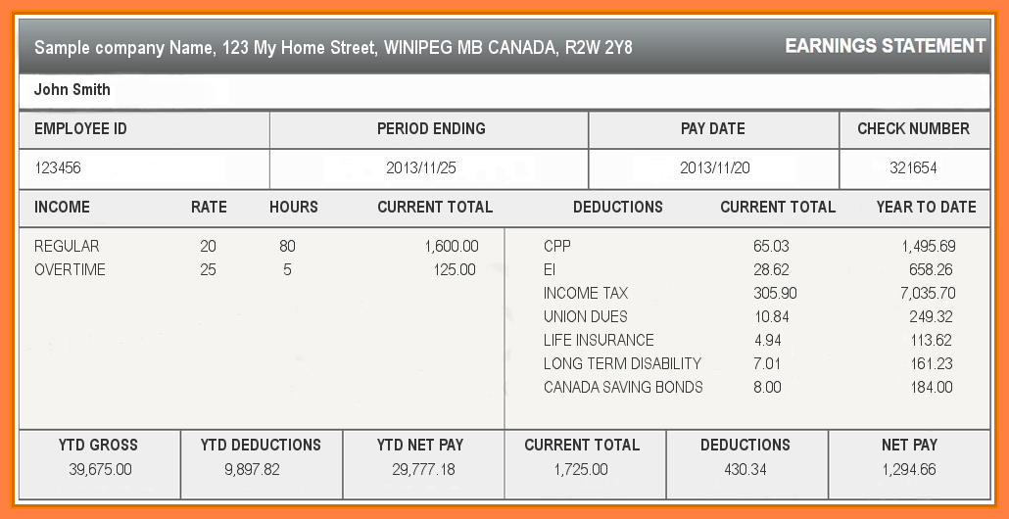
Employee ID #:A number used by your employer to identify you in their electronic system
Pay Period or Period Ending: This is the date range you are being paid for. It is usually biweekly (every two weeks). However, in this program you are paid on a weekly basis.
Pay Date: This is the date that you can cash the cheque. The cheque is no longer valid (stale-dated) six months from that date.
Cheque #: The number is used by employers to enable them to track the cheque in case of loss
Pay Rate: This is the amount you are paid per hour. Some people make a salary that does not depend on their hours worked. On their pay stubs, they see only the amount of pay in the pay period, but not an hourly rate of pay.
Hours: This is the number of hours in this pay period or period ending. Check to make sure it is correct. If you have worked more hours, speak with your employer. Always keep track of your hours worked. If your employer uses a time clock, always remember to punch in and out so your hours are recorded.
Gross income: The total amount of pay before any deduction is taken out. On the above pay stub it is titled “CURRENT TOTAL”
Year to date: The total amount of pay and deductions from the beginning of the year through the current pay period.
Deductions
Deductions are the amounts that are subtracted from your gross pay amount as required. Usually these deductions are referred to as MERCS, which is an acronym for “Mandatory Employment Related Costs." This means payments that the Employer is required by law to make in respect of employees including, but not restricted to, those payments required for Employment Insurance (EI), Canada Pension Plan (CPP), and Income Tax.
Employment Insurance (EI): A percentage of gross income paid by employees and employers to provide temporary payments if workers become unemployed.
Canada Pension Plan (CPP): A percentage of gross income paid by employees and employers to provide income when workers retire or become disabled, or for survivor benefits.
Federal Income Tax: Your employer will calculate the amount of federal income tax to deduct from your earnings. The tax system in Canada is ‘progressive’. This means that the more income you make, the higher percentage of your income will go toward taxes.
Other: Other deductions may include private pension plans, health insurance premiums, union dues and professional fees, transfers to your registered savings plans and charitable donations.
Net Pay: This is the gross pay amount minus all the required deductions – the amount you take home or the amount that shows on your pay cheque.


Time Sheets
A time sheet is one method for recording the amount of a worker's time spent on each job. Time sheets are filled out daily. The sheet may either be filled out by the employer or the employee. For the duration of this program, time sheets will be required to be to be filled out and signed by your employer. They must be submitted to the SMFN Education Department on Fridays by 12pm to allow enough time for payroll processing the following week.
You will only be paid for the hours that you work. There is no sick time, overtime, or holiday pay. You are paid a week behind. Your first pay cheque will be issued the second Thursday of the program and for the following four Thursdays.
Pay Day Schedule:
1st payday: Thursday July 9 2026
2nd payday: Thursday July 16 2026
3rd payday: Thursday July 23 2026
4th payday: Thursday July 30 2026
5th payday: Thursday August 6 2026
Please keep track of your own hours



Work Ethic
Work Ethic is a cultural custom that advocates being personally accountable and responsible for the work that one does and is based on a belief that work has essential value. The term is often applied to characteristics of people at work. For example, Work Ethic is frequently mentioned as a characteristic of good workers. Regardless of the context, work ethic this is usually associated with people who work hard and do a good job, and their performance is usually above average.
The following steps enhance work ethics:
- Attendance
Attendance and punctuality often have a large impact on individual and team success. Tardiness or absenteeism can also profoundly impact job performance and retention of team members.
- How you can maintain good attendance:
- Make work a high priority
- Know your schedule
- Get enough sleep
- Arrange your transportation and childcare
- Inform your manager of an absence

- Character
A work place facility expects employees to work together toward achieving the vision and mission of the facility. The sensible employee who is interested in having a good relationship with his employer will try to help the employer attain success. Thus the employer expects employees to develop certain desirable traits that will help them to perform their jobs well so that the organization can succeed.
Some of the traits that are appreciated by employers include the following
- Loyalty
- Honesty
- Self-responsibility
- Initiative
- Dependability trustworthiness
- Reliability
- Self-discipline

- Teamwork
It is vital that an employee respect rights of others, is cooperative and displays mannerly behaviors. It is important not only to their personal success and advancements, but also to that of their team members and to the facility.
Teamwork involves the following aspects:
- Respecting the rights of others
- Being a team player
- Being cooperative
- Being assertive
- Displaying a client service attitude
- Seeking opportunities for continuous learning
- Demonstrating mannerly behavior
- Respecting confidentiality

- Appearance

A person makes their first impression of someone in 3 seconds. If you appear unkempt and wrinkled, someone may think that you will do sloppy work. If you dress professional, your first impression will be excellent.

- Attitude

It is very important to demonstrate a positive attitude, appear self-confident, and have realistic expectations for yourself. Developing and maintaining a positive attitude involves setting realistic goals for ourselves at work. These goals should be challenging, but obtainable taking in consideration the people you are working with.

- Productivity

In order to be a productive employee must follow safety practices, policies and procedures, and be effective in following directions.

- Organizational Skills

Employers consider effective time management and organizational skills as excellent work habits. To begin managing wisely the time you spend at work and to manage your life at home and work simultaneously, you need to know and to put into practice some good time management techniques.

Simple techniques

- Believe- as you enter the work place that you are in control
- Ask for help – help comes in many forms, so ask for it
- Prioritize – what is the most important
- Set timetables – list what you want to achieve in a specific time period and what is still pending
- Spend time wisely and effectively
- Decision making
- Paying attention to details

- Communication

Verbal and nonverbal communication must be clear, to the point, empathic, and one must keep in mind that we must always treat others as we would like others to treat us.

- Cooperation

Cooperation involves developing good working relationships, following the chain of command, being good at conflict management, demonstrating leadership skills, being a good problem solver, and most of all being a real team player.

- Respect

It cannot be emphasized enough that every working relationship from the top to the bottom of the chain of command is based on respect. People with good work ethics do not engage in harassment of any kind. Working in today’s world is very demanding and it necessitates its workers to demonstrate high and positive attitudes in order to be responsible and productive employees.

What does respectful behavior look like? ________________________________________________________________________________________________________________________________________________________________________________________________________________________________________________________________________________________________________________________
Why is respectful behavior important in a work environment? ________________________________________________________________________________________________________________________________________________________________________________________________________________________________________________________________________________________________________________________
What work ethics are my strongest? ________________________________________________________________________________________________________________________________________________________________________________________________________________________________________________________________________________________________________________________
What work ethics could I improve upon? ________________________________________________________________________________________________________________________________________________________________________________________________________________________________________________________________________________________________________________________
How can I improve upon them? ________________________________________________________________________________________________________________________________________________________________________________________________________________________________________________________________________________________________________________________
What does my employer expect of me? __________________________________________________________________________________________________________________________________________________________________________________________________________________________________________
What are my expectations for myself? ________________________________________________________________________________________________________________________________________________________________________________________________________________________________________________________________________________________________________________________
Was there a presentation regarding Work Ethics? Yes ________ No__________
Name of presenter? _________________________________________________

What did I learn from the presentation about Work Ethics? ____________________________________________________________________________________________________________________________________________________________________________________________________________________________________________________________________________________________________________________________________________________________________________________________________________________________________________________________________________________
Human Rights and Harassment in the Workplace
In New Brunswick, as in the rest of Canada, people are protected by law from many types of discrimination. This law is the New Brunswick human rights act. The New Brunswick Human Rights Commission enforces the law.
The Human Rights Commission is a provincial government agency. It promotes equality and investigates and tries to settle complaints of discrimination and harassment. If a complaint cannot be settled, a human rights tribunal can hear all the evidence. If it decides that there was discrimination, it can issue orders to correct it. The commission also works to prevent discrimination by promoting human rights and offering educational opportunities to employers, service providers and the general public.
The Human Rights Act is a provincial law that prohibits discrimination and harassment in:
- Employment
- Housing Public Service such as schools, stores, hotels, hospitals, police and government services
- Publicity
- Certain associations

The grounds of prohibited discrimination are:
- Race
- Color
- National origin
- Place of Origin
- Ancestry
- Religion
- Age
- Marital status
- Sex
- Sexual Orientation
- Physical or mental incapability’s
- Social condition, which includes sources of income, levels of education and occupation
- Political belief or activity

If you think you are being discriminated against or harassed based on the prohibited grounds listed above you can file a complaint with the Human Rights Commission. You do not need to be a citizen or landed immigrant. It does not cost anything, and it is illegal for someone to penalize you because you file a complaint.

Harassment
Behavior which serves no legitimate purpose and which the instigator knows, or ought reasonably to know, has the effect of creating an intimidating, humiliating, hostile or offensive environment.
Examples include but are not limited to: bullying, intimidation, coercion, physical assault, vexatious or malicious comment, or the abuse of power, authority or influence. Behavior conducted in whole or in part through electronic means. shall be included within this definition. The reasonable exercise of administrative or academic authority does not of itself constitute harassment.

Sexual Harassment
Sexual Harassment: Conduct of a sexual nature such as, but not limited to, verbal abuse or threats of a sexual nature, unwelcome sexual invitations or requests, demands for sexual favors, or repeated innuendos or taunting about a person's body, appearance or sexual orientation, constitutes sexual harassment when:
- submission to such conduct is made either explicitly or implicitly a term or condition of an individual's employment, academic status or academic accreditation, or
- submission to or rejection of such conduct by an individual is used as the basis for employment, or for academic performance, status or accreditation decisions affecting such individual,
- such conduct interferes with an individual's work or academic performance, or
- such conduct creates an intimidating, hostile or offensive working or academic environment
What Discriminatory grounds are identified under the Human Rights Act?
____________________________________________________________________________________________________________________________________________________________________________________________________________________________________________________________________________________________________________________________________________________________________________________________________________________________________________________________________________________

Name the 3 distinct types of harassment and give an example of each.
________________________________________________________________________________________________________________________________________________________________________________________________________________________________________________________________________________________________________________________________________________________________________________________________________________________________________________________________________________________________________________________________________________________________________________________________________________________________________________
What do I do if I feel I am being harassed?
______________________________________________________________________________
______________________________________________________________________________
______________________________________________________________________________
______________________________________________________________________________
______________________________________________________________________________
______________________________________________________________________________
______________________________________________________________________________
Was there a presentation regarding Human Rights and Harassment in the Workplace?
Yes ________ No__________
Name of presenter? _________________________________________________
What did I learn from this Presentation?
________________________________________________________________________________________________________________________________________________________________________________________________________________________________________________________________________________________________________________________

The Job Interview
A job interview is a conversation between a job applicant and a representative of an employer. It is conducted to assess whether the applicant should be hired. Interviews are one of the most popularly used methods for employee selection. Interviews may vary in the extent to which the questions are structured, from a totally unstructured conversation, to a structured interview in which an applicant is asked a predetermined list of questions selected by the employer. A job interview typically precedes the hiring decision.
Interviewing Skills
What steps should you take to prepare for an interview?
__________________________________________________________________________________________________________________________________________________________________________________________________________________________________________________________________________________________________________________________________________________________________________________________________________________________________________________________________________________________________________________________________________________________________

What happens during an Interview?
________________________________________________________________________________________________________________________________________________________________________________________________________________________________________________________________________________________________________________________

How should you behave at an interview?
________________________________________________________________________________________________________________________________________________________________________________________________________________________________________________________________________________________________________________________

Was there a presentation regarding Interview Skills? Yes ________ No__________
Name of presenter? _________________________________________________

What did I learn from this Presentation?
______________________________________________________________________________________________________________________________________________________________________________________________________________________________________________________________________________________________________________________________________________________________________________________________________
Did you go meet your employer prior to your placement? Yes _________ No__________
If No – What was the reason you did not?
________________________________________________________________________________________________________________________________________________________________________________________________________________________________________________________________________________________________________________________
If Yes, Please give a description of what you talked about?
________________________________________________________________________________________________________________________________________________________________________________________________________________________________________________________________________________________________________________________

First Aid & CPR Training
What is First Aid & CPR Training?
For the purpose of this program, First Aid & CPR Training is a comprehensive two-day course offering first aid and cardiopulmonary resuscitation (CPR) skills for those who need training due to work requirements. It is taught by a trained First Aid Instructor. Those who do not have First Aid & CPR Training will be required to take the two day training and complete successfully, which includes the following:
- ability to comprehend and successfully demonstrate all required skills, including critical steps;
- 100% attendance and participation;
- 75% min. passing grade on a written closed book knowledge evaluation

The Instructor will ensure you know exactly what is expected.

Grades 9, 10, 11, and 12 students, if you did First Aid & CPR Training in the previous year and completed it successfully, then you do not have to re-take it. All other students will be required to take it, or have it renewed
Were you required to take First Aid & CPR Training? Yes________ No__________
If yes, what did you like the most about it?
________________________________________________________________________________________________________________________________________________________________________________________________________________________________________________________________________________________________________________________
What did you like the least about it?
________________________________________________________________________________________________________________________________________________________________________________________________________________________________________________________________________________________________________________________
How many years is your First Aid & CPR Training valid for? _________________________
Name of the instructor: _________________________________________________________

Entrepreneurship
What did you learn about this business? ______________________________________________________________________________________________________________________________________________________________________________________________________________________________________________________________________________________________________________________________________________________________________________________________________
What are the biggest challenges entrepreneurs are faced with? __________________________________________________________________________________________________________________________________________________________________________________________________________________________________________________________________________________________________________________________________________________________________________________________________________________________________________________________________________________________________________________________________________________________________
Can you see yourself running your own business? Why or Why not? _____________________________________________________________________________________________________________________________________________________________________________________________________________________________________________________________________________________________________________________________________________________________________________________________________
Was there a presentation regarding Interview Skills? Yes ________ No__________
Name of presenter? _________________________________________________
What did I learn from this Presentation?
__________________________________________________________________________________________________________________________________________________________________________________________________________________________________________
YOUR CAREER PLACEMENT
What is the name of the Company you are doing your career placement with?
_____________________________________________________________________________
What do they do there?
__________________________________________________________________________________________________________________________________________________________________________________________________________________________________________
Your Mentor:
Mentors Name: _________________________________________________________________
Job Title: _____________________________________________________________________
What department is this position in? ________________________________________________
Describe your mentors’ position?
________________________________________________________________________________________________________________________________________________________________________________________________________________________________________________________________________________________________________________________
What are his/her main responsibilities?
________________________________________________________________________________________________________________________________________________________________________________________________________________________________________________________________________________________________________________________
How many people does your mentor supervise? ______________________________________
What are their titles?
____________________________________________________________________________________________________________________________________________________________
What do they do?
____________________________________________________________________________________________________________________________________________________________
Is your supervisor responsible for a budget? Yes _________ No __________
Is your supervisor responsible for performance management? _____________
What is Performance Management?
________________________________________________________________________________________________________________________________________________________________________________________________________________________________________________________________________________________________________________________
What are three key challenges your mentor deals with?
____________________________________________________________________________________________________________________________________________________________________________________________________________________________________________________________________________________________________________________________________________________________________________________________________________________________________________________________________________________
What training and qualifications are required to do this job?
__________________________________________________________________________________________________________________________________________________________________________________________________________________________________________
What does your mentor like about his/her career?
________________________________________________________________________________________________________________________________________________________________________________________________________________________________________________________________________________________________________________________
How did he/she get into the particular career?
________________________________________________________________________________________________________________________________________________________________________________________________________________________________________________________________________________________________________________________
What are two realities of their job your mentor dislikes?
________________________________________________________________________________________________________________________________________________________________________________________________________________________________________________________________________________________________________________________
How does your mentor organize his/her work… what tools does he/she use?
____________________________________________________________________________________________________________________________________________________________
How does your mentor prioritize his/her work?
________________________________________________________________________________________________________________________________________________________________________________________________________________________________________________________________________________________________________________________
Describe three personal strengths you have observed from your mentor?
__________________________________________________________________________________________________________________________________________________________________________________________________________________________________________________________________________________________________________________________________________________________________________________________________________________________________________________________________________________________________________________________________________________________________

How do you feel these strengths make him/her good at what they do?
__________________________________________________________________________________________________________________________________________________________________________________________________________________________________________
About You and Your Career Placement
What do you like about this career/occupation?
____________________________________________________________________________________________________________________________________________________________________________________________________________________________________________________________________________________________________________________________________________________________________________________________________________________________________________________________________________________
What strengths do you have that match this career?
________________________________________________________________________________________________________________________________________________________________________________________________________________________________________________________________________________________________________________________
What are some of your limitations that you would have to improve to be successful?
________________________________________________________________________________________________________________________________________________________________________________________________________________________________________________________________________________________________________________________

Do you see yourself choosing a similar position? Why or why not?
__________________________________________________________________________________________________________________________________________________________________________________________________________________________________________
What steps do you have to take in order to get into this profession?
________________________________________________________________________________________________________________________________________________________________________________________________________________________________________________________________________________________________________________________
The Work Environment

What are the hours of work? _________________________________________
What is the dress code? ____________________________________________________________________________________________________________________________________________________________
What type of equipment is used?
________________________________________________________________________________________________________________________________________________________________________________________________________________________________________________________________________________________________________________________
Did you get to use the equipment? Yes___________ No ___________
How much of this work is done with the aid of a computer?
____________________________________________________________________________________________________________________________________________________________
Did you get to assist with any computer work? Yes ___________ No _____________

Describe the work environment.
________________________________________________________________________________________________________________________________________________________________________________________________________________________________________________________________________________________________________________________

Is this a company that you could see yourself working for? Why or Why not?
______________________________________________________________________________________________________________________________________________________________________________________________________________________________________________________________________________________________________________________________________________________________________________________________________



Career Success
What is Career Success?
The definition of career success can be very personal. For one it may be the prestige of a title, while for another it may be the amount of money earned. For another it may just be the job itself. When you are defining your career, be sure to stay focused on what’s important to you.
Your success is a journey that happens over time. It may have multiple highs and lows. It can be a bit like stepping blocks, where one success will lead to another success. Setbacks may occur and mistakes will be made, but this how we learn. You simply pick up and keep moving towards your goal.

What do you think it takes to be successful in a career?
________________________________________________________________________________________________________________________________________________________________________________________________________________________________________________________________________________________________________________________

Identify three individuals that you feel are successful and explain why.

1.__________________________________________________________________________________________________________________________________________________________
2.__________________________________________________________________________________________________________________________________________________________
3.__________________________________________________________________________________________________________________________________________________________

What types of careers have you thought about?

1.____________________________________________________________________________
2.____________________________________________________________________________
3.____________________________________________________________________________
4.____________________________________________________________________________
5.____________________________________________________________________________

Resume Basics for High School Students

What is a resume?
A resume is a one – two page formal document submitted to job recruiters / employers as means to see a list of an applicant's work experience, education and skills. The document is designed to provide a summary of an applicant's qualifications for a particular job - it is not usually meant to provide a complete picture. A good resume gives the potential employer enough information to believe the applicant is worth interviewing.
When creating a resume keep in mind that your resume represents a first impression of you. It represents you. Tips: be organized, consistent, use a good layout, pay attention to spelling, and keep it short (1-2 pages).

Why do I need one?

Most employers request that potential employees submit a resume when responding to and advertised job competition or applying for a position. The data contained in your resume is used to determine if you have the desired experience and qualifications for a particular position and/or whether you will be given further consideration for the position.

What is a job competition?

A competition is when an employer advertises an opening and invites potential candidates for an interview. A resume typically must be submitted for each position advertised as most employers do not automatically review their general applications to see if they have candidates on file. Pay close attention to the job advertisement. Your resume should match the employer’s hiring needs.

What is a general application?

When an individual contacts a company looking for any available work it is considered to be a general application

How often does it need to be updated?

Your resume should be kept up to date to ensure that you have added any new work experience, skills and/ or training. It should also be reviewed before applying for a position to ensure that you have highlighted relevant experience and skills.

How long are they kept on file?

Most organizations keep general applications on file for one year.

What should a resume look like? Is there a standard format?

Resumes can be as creative and colorful as you wish. They should however contain relevant data regarding experience, education, skills, abilities, language capabilities, contact information, certificates of accomplishment and any other relevant information to convince the potential employer of your employment potential.

How do I know what skills and abilities I have?

We are all good at something .Again the skills you document in your resume should be ones relevant to becoming a good employee. Work Habits, Motivational Factors, Human Relations Skills, Problem Solving Abilities, Vocational Incentives, and Lifestyle Priorities are excellent examples of relevant information. It is also quite appropriate to mention your Career Cruising Results and Career Success potential.

What if I have never worked before?

We often sell ourselves short in this area. Volunteer work, community work, fundraising activities, babysitting, lawn care, tutoring, club participation, etc., are all examples of paid and unpaid work experience that demonstrate personal initiative, responsibility, and interest.

Should I mention Hobbies?

Involvement with clubs, organizations, hobbies etc., is also means by which to demonstrate personal motivation. It is not required information, however, if relevant can be quite useful.

What about References?

Typically individuals identify they can provide references “upon request”. Attaching letters of recommendations from teachers, former employers, etc., is also appropriate. You do not have to include references with your resume (unless specifically requested in a job competition). Typically, references will ask for three. Your references can be work related, education related, character related, community/extra-curricular related. Always ensure you have the person’s permission that you are using as a reference. A reference includes the person’s full name, job title, company/organization, and up to date contact information.

What is a Cover Letter?

A cover letter should be included with your resume .It is a brief introduction and summary of one’s qualifications as related to the opening. Covering letters should be revised with each application to ensure it is specific to the position.

The next few pages contain samples of a cover letter and resume. There will be other formats provided as handouts.

Sample Cover Letter

Jane Doe
123 Your street,
Your city/town
New Brunswick
E3E 3E3

July 23, 2018

Dear Ms. Avery;

Subject: Competition Number 284, Customer Services Coordinator

Please accept the attached resume as my application of Employment for the position of Customer Services Coordinator with Delco Corporation. I have worked in the Customer Services Industry for 5 years and have proven my ability to provide good customer services. I thoroughly enjoy working with customers and am very interested in the opportunity to advance my career in this field
I look forward to meeting with you to discuss my qualifications for this position.

Sincerely,

Jane Doe
Sample Resume
Jane Doe
123 Your street,
Your City/Town
New Brunswick
E3E 3E3

123-4567 (Home)
234-5678 (Cell)

Objective: To secure full time employment in the Customer Services Field
Competition Number: 284
Position: Coordinator Customer Services

Skills and Abilities:
I am a hardworking, conscientious and enthusiastic individual who enjoys serving the public. Highly empathetic, patient and tactful, I have very good Human Relations Skills and understand the importance of outstanding customer service. Well organized, mature and responsible, I work well with a team as well as autonomously.

Languages: I am fluent in English and French and have a good understanding of Maliseet.

Previous Work Experience:
July 2002- May-2005: Cendent Call Center, Hanwell Road, Fredericton
Job Title: Customer Services Representative
Responsibilities: I am currently responsible for all incoming calls from region 6, the New England area. My main responsibility is to ensure high quality service is given to customers looking for hotel and car rental reservations. My calls are recorded and reviewed on a weekly basis. To date I have received 8 awards for exceeding customer expectations.
Reason for seeking alternative employment: My position is on a part time basis only .I am hoping to find regular employment in my field of choice, Customer Services as well as the opportunity for advancement.

Jan2, 2000 – July 2002: Sarah’s Pizza Parlor, Highway Avenue, Fredericton
Job Title: Waitress
Responsibilities: At Sarah’s I was responsible for waiting on and serving customers. This position taught me patience, understanding and the value of Good customer service. It also required excellent memory and good organizational skills
Reason for Leaving: The Call center position offered the opportunity to earn more money and enhance my customer service skills.

1997-2000: During my high school years I worked at various odd jobs such as; babysitting, painting, lawn care, newspaper delivery and general laborer type work.

Education:
I graduated from Leo Hayes High School in June 2000
I hold a level three certificate of proficiency in French

Other Training: I have completed the Safe Drivers Program, First Aid and CPR and am qualified as a Lifeguard.
Hobbies: I enjoy swimming, competitive sports and travel.

References: Available upon request

Resume Practice Outline

Name
Street
City, Town
Province
Postal Code

Phone Numbers

Objective: ____________________________________________________________________________________________________________________________________________________________

Competition Number: If applicable
Position: ____________________________________________________________________________________________________________________________________________________________
Skills and Abilities:
________________________________________________________________________________________________________________________________________________________________________________________________________________________________________________________________________________________________________________________

Languages: ___________________________________________________________________

Previous Work Experience: (Start from most recent job)
Dates: ____________________Company: _______________________________________
Job Title: _____________________________________________________________________
Responsibilities: __________________________________________________________________________________________________________________________________________________________________________________________________________________________________________
Reason for leaving: ____________________________________________________________________________________________________________________________________________________________

Dates: ____________________ Company: __________________________________________
Job Title: _____________________________________________________________________ Responsibilities: __________________________________________________________________________________________________________________________________________________________________________________________________________________________________________
Reason for Leaving: ____________________________________________________________________________________________________________________________________________________________

Volunteer or Other paid work experience:
____________________________________________________________________________________________________________________________________________________________

Education:
____________________________________________________________________________________________________________________________________________________________

Other Training:
____________________________________________________________________________________________________________________________________________________________

Licenses, Certificates:
____________________________________________________________________________________________________________________________________________________________

Hobbies: __________________________________________________________________________________________________________________________________________________________________________________________________________________________________________

References: Available upon request

****

Submit your resume in a business envelope. Never fold it. Be as professional as possible.

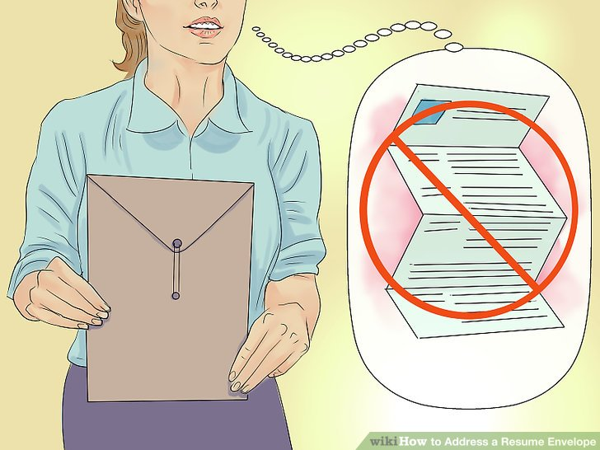

Was there a presentation regarding Resumes & Cover Letters.? Yes ________ No__________
Name of presenter? _________________________________________________
What did I learn from this Presentation?
__________________________________________________________________________________________________________________________________________________________________________________________________________________________________________

Final Student Evaluation

To be completed by your career placement Mentor.

Date: ____________________________________

Name of student: _______________________________________________________________

Did the student miss any time? Yes _________________________ No ____________________

If so, how many days? __________________________________

Was he /she appropriately dressed for work? Yes _________________ No_________________

Was the student’s behavior friendly and professional? ____________________________________________________________________________________________________________________________________________________________

Did the student perform all duties asked of him/her? ____________________________________________________________________________________________________________________________________________________________

Did the student display initiative? Yes ___________________ No________________________

If yes, How so? __________________________________________________________________________________________________________________________________________________________________________________________________________________________________________

Did the student ask questions regarding the profession? Yes _____________ No_____________

Did the student ask questions regarding your background and the training required to work in your field?
________________________________________________________________________________________________________________________________________________________________________________________________________________________________________________________________________________________________________________________
Did you feel the student was genuinely interested in the profession? Please provide a brief description.
_______________________________________________________________________________________________________________________________________________________________________________________________________________________________________________________________
Did you feel the student made the most of his/her experience? If so, How?___________________________________________________________________________________________________________________________________________________________________________________________________________________________________________________________________________________________________________________

Would you take the student back again? Yes____________ No ___________ Please provide a brief description for your answer ________________________________________________________________________________________________________________________________________________________________________________________________________________________________________________________________________________________________________________________
Other General Comments/Observations; ________________________________________________________________________________________________________________________________________________________________________________________________________________________________________________________________________________________________________________________

Mentor’s signature: _____________________________________________________________

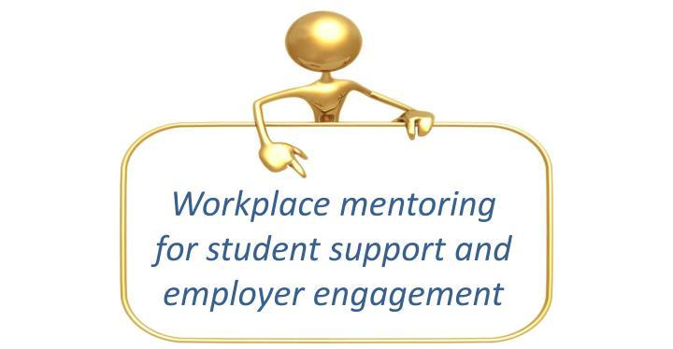

NOTES:

http://www.unb.ca/humanrights/harassment.html

