ST. MARY’S FIRST NATION
EDUCATION DEPARTMENT

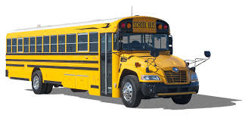

SCHOOL BUS
Policy & Procedure Handbook



The purpose of this handbook is to provide information regarding laws, rules, and guidelines to safely operate a school bus therefore providing safe transportation for students. It has been developed in accordance with Federal and Provincial Motor Vehicle Laws, New Brunswick’s Education and Early Childhood Development K-12, and St. Mary’s First Nation Human Resources Policy & Procedures.

Revised February 2023
by
SMFN Education Department
K-12 Program
150 Cliffe St. 2nd Floor
Fredericton NB
E3A 0A1

Phone: 506-459-2219

This handbook is NOT intended to take the place of any Provincial or Federal motor vehicle laws or other official publications of the St. Mary’s First Nation Education Department Policies and/or St. Mary’s First Nation Human Resource Policy & Procedure Manual approved by Chief & Council NEW DATE.

This manual is to be used in conjunction with any and all Provincial, Federal & St. Mary’s First Nation Human Resource & Post-Secondary policy and procedures.



Forward

In no other area of education do we accept more responsibility for student welfare than in transporting students by school buses and / or other approved transportation vehicles, to and from school, school related activities, and recreational activities. The safe transportation of students requires the dedicated efforts of many individuals associated with the educational system. This includes the New Brunswick Department of Safety, the New Brunswick Department of Education, the local school board, the superintendent and staff, the vehicle maintenance and service personnel, teachers, parents, students, St. Mary’s First Nation and most important --- the driver of the bus.

Being a School Bus Driver

School bus drivers are highly trained professionals who have accepted the tremendous responsibility of transporting young people. Before drivers are allowed to transport students, they must complete the following:

- Successfully complete a motor vehicle test Class and possess a Class 2 N.B. Drivers License
- A criminal record check
- Submit a clean Drivers Abstract
- Pass a physical examination
- Successfully complete a series of tests administered by the N.B. Department of Safety, Motor Vehicles Division
- Bus Driver Training
- A drug screening test if they need a commercial license
- First Aid/CPR

Every precaution is taken to assure that school bus drivers in New Brunswick are physically and mentally qualified to drive a bus.

Every driver should have a copy of this handbook and be thoroughly familiar with the contents. In addition to this handbook drivers should also be familiar with school district and/or St. Mary’s First Nation policies.

Those who master the special knowledge and skills required to drive a school bus acquire the respect of other drivers, their employers, school officials, parents, and the public. As professionals, they enjoy a position of being some of the safest, most knowledgeable and considerate drivers on our streets and highways.



Driver Disqualification

A school bus driver or driver of any other vehicle used by St. Mary’s First Nation for the purpose of transporting students to and from school either on or off reserve or any applicant for a school bus operator’s certificate shall be disqualified for the issuance of a certificate upon receipt of information showing good cause. Good cause shall include but not be limited to the following:

1. Arrest, conviction, or indictment involving the commission of a crime where the applicant used a motor vehicle to commit said crime.

2. Arrest, conviction, or indictment for deviate behavior such as rape, deviate sexual relations, or sexual assault.

3. Arrest, conviction, or indictment for an offense resulting in the corruption or delinquency of minor children.

4. Arrest, conviction, or indictment for operating a motor vehicle under the influence of alcohol or controlled drugs, leaving the scene of a motor vehicle accident, reckless operation of a motor vehicle, or operating to endanger.

5. A conviction within the preceding 10 years for:
a. Operating a motor vehicle under the influence of alcohol or controlled drugs,
b. Leaving the scene of a motor vehicle accident,
c. Reckless operation of a motor vehicle; or
d. Driving to endanger, unless in the judgment of the commissioner, the applicant’s reputation is such that the conviction is unlikely to adversely affect the applicant’s physical, mental or moral fitness to operate a school bus.

6. Arrest, conviction, or indictment involving the manufacture, illegal transportation, possession, sale or use of controlled drugs.

7. Arrest, conviction, or indictment of either New Brunswick motor vehicle or criminal laws or laws of other jurisdictions, which have a direct bearing on the driver’s fitness to hold a school bus driver’s certificate.

8. Involvement in a motor vehicle accident that has a direct bearing on the applicant’s fitness to drive.

9. A determination that the driver is an abuser of alcohol, prescription drugs, or controlled substances.

10. If financial security is required from an applicant and is not on file with the department.

11. A determination that a driver is a danger to him/herself and/or to children.
OPERATION OF A SCHOOL BUS / MULTI-PURPOSE VEHICLE

The purpose of this section is to provide information on basic procedures needed to operate a school bus safely and efficiently while transporting students. Once these basic procedures are learned, they should be practiced until they become automatic. By developing these procedures to their utmost, the driver can devote their attention to changing traffic conditions.

PRE-TRIP & POST-TRIP INSPECTION

It is the responsibility of the school bus driver or a person designated to perform a daily pre-trip and post-trip inspection (referred to above as vehicle inspections) of the school bus and equipment. The following emergency equipment is required on a school bus or multi-purpose vehicle:
1. Fire extinguisher
2. First Aid Kit
3. Three reflectorized triangles
4. Chock Blocks (not required on multi-purpose vehicles)
5. Bodily Fluid Spill Kit

The goal of both the pre-trip and post-trip inspection requirements is to ensure safer vehicles and prevent accidents. These inspections should take place in time to allow for proper repairs or vehicle replacement, if necessary. Any defects relating to the safe operation of a school bus, such as a malfunction of the eight-light warning system, low tire inflation, brake problems, etc. should be reported in person or by telephone immediately to the SMFN Education Department. This should also be documented on the vehicle condition report. A school bus or multi-purpose vehicle that fails to pass either pre-trip or post-trip inspection shall not be used to transport passengers.

Pre-Trip Inspection
A pre-trip inspection is performed prior to each trip to identify problems that could cause a breakdown or accident.

1. Be satisfied that the vehicle is in safe operating condition.
2. Review the last vehicle inspection report required to be carried on the bus.
3. Sign the last vehicle inspection report if a noted defect has been corrected. By signing this report, the driver acknowledges that the report has been reviewed and any defect has been corrected.

Post-Trip Inspection:
At the end of a driver’s day of work, he/she must complete a post-trip inspection. This is the final inspection before the vehicle inspection report is completed and signed.

PRE-TRIP VEHICLE INSPECTION

DAILY CHECKLIST:
_____ Fluid level in engine / power steering / hydraulics / brake / clutch / coolant - if applicable
_____ All engine belts / hoses for leaks and wear
_____ Tires for cuts / pressure / loose nuts / rims / wear
_____ All lights are clean and working
_____ Brake and clutch operation
_____ Visible leaks around and under the vehicle
_____ Start engine / check all gauges and instruments / horn / back up alarm
_____ Glass and body for damage
_____ Windshield wipers / fluid
_____ Check for unusual noises
Note: Daily items should be checked by the driver of the vehicle.
WEEKLY CHECKLIST:
_____ Transmission / differential / transfer case / gear boxes / hydraulic system for fluid level and leaks, if applicable;
_____ Battery fluid / terminals / cables;
_____ Loose bolts / loose or bare wires;
_____ Exhaust system for looseness and leaks / springs;
_____ Air filter / connections;

Note: Weekly items should be checked by individual assigned the responsibility for the repairs and general maintenance of the vehicle.
IMPORTANT REMINDER
If you are traveling outside the Province, verify if there are specific requirements, special permits and/or the need to complete a logbook (depending on the size of the vehicle).

VEHICLE INSPECTION REPORT – POST-TRIP INSPECTION

Every school bus carrier shall require and every school bus driver shall complete a vehicle inspection report in duplicate, at the completion of each day that shall indicate any defects discovered which may affect the safety of operation or could result in a mechanical breakdown. The following procedures relative to reporting shall be followed:

- If no defects are found, the report shall so indicate. One copy of the report shall be submitted to the St. Mary's Education Department at the end of the day, and the other copy shall remain on the bus.
- If a defect is found, a copy of the report shall be turned into St. Mary's Education Department at the end of the day, and the other copy shall remain on the bus.
- Any defect that would cause the bus to be put out-of-service shall be corrected before the bus is used to transport students.
- In all instances, the driver shall sign the report.
- In all instances, a legible copy of the last vehicle condition report shall be carried on the bus.

The vehicle report must contain the following information:

1. Full company name (St. Mary’s First Nation)
2. Bus number
3. Mileage
4. Date
5. Time
6. Location
7. Defect (if found) with an explanation
8. Condition of the vehicle, and
9. Driver’s signature (legible).

If repairs are necessary, the school bus carrier or agent must sign the vehicle condition report attesting to the fact that the repairs have been made. The next driver of that bus must also sign the vehicle inspection report after the pre-trip to assure the defects have in fact been corrected. All signatures must be LEGIBLE.

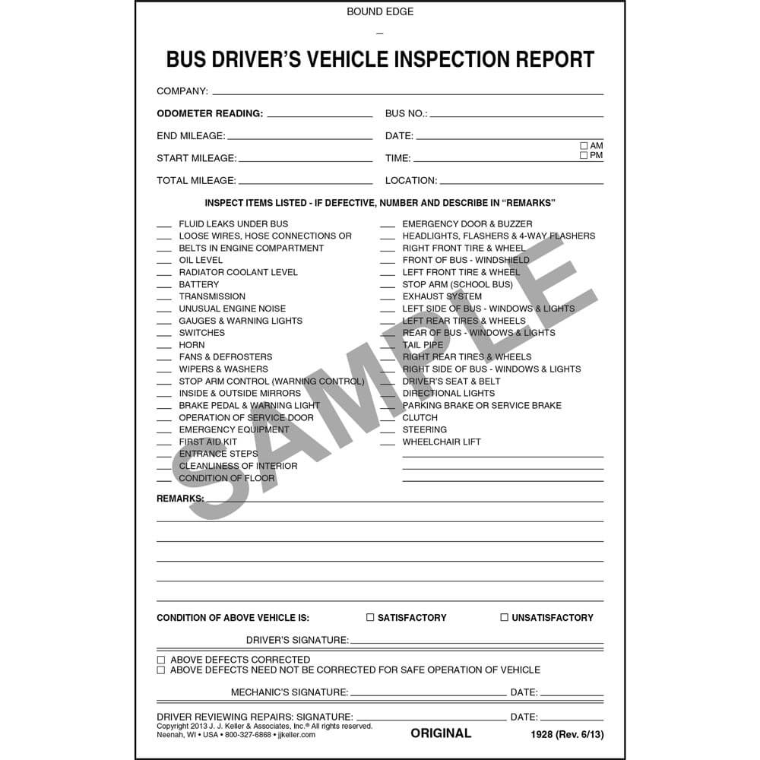
DAILY INSPECTION

This pre-trip inspection must be completed in accordance with Regulation 2001-51 Section 14 (1) (a) Education Act. A school bus driver must carry out a thorough inspection each day. A daily inspection will ensure the vehicle is safe to operate and help prevent delays due to breakdown, and avoid costly repairs. Items that may jeopardize safe operation should be dealt with immediately. The following page provides the steps.

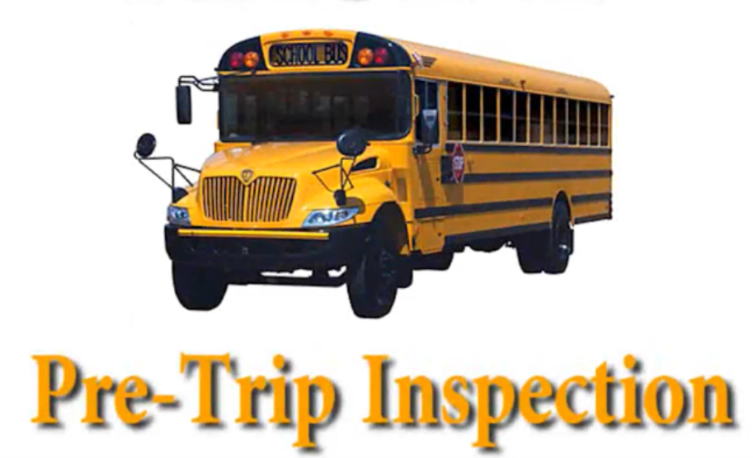

STEP 1: - WALKAROUND  1. Check vehicle log book  2. Block wheels  3. Visible damage or leaks  4. Mirrors, front lights, lettering, windshield, hood, grill and bumper  5. Open hood  a) Wipers, inspection sticker  b) Turbo, manifold, engine for excessive leaks,  electrical wires and connectors,  c) Compressor, pulleys, tension and condition of  belts, hoses, fan and radiator shroud  d) Check all fluids  e) Steering box, linkage  f) Spring, shackles, u-bolts and shock absorbers  g) Brake hoses and slack adjusters  h) Tires and wheels  i) Hood hinges and latches  6. Windows, body and paint  7. Battery and battery box  8. Underneath the bus  a) Engine leaks, transmission, drive shaft, joints and protection guard  b) Check exhaust, air dryer, air reservoirs and hoses  c) Rear suspension, springs, shackles, u-bolts and axle  9. Inside and outside rear tires and wheels  10. Back of the bus  a) Lights, lettering and windows  b) Emergency exit (open from outside)  c) Bumper and tailpipe  11. Fuel cap, tank and impact guard | STEP 2: - IN THE BUS  1. Check passenger door, steps and handrail  2. Start the engine  3. Verify oil pressure and all gauges  4. Check all switches and controls  5. Mirrors  6. Side windows and windshield  7. Horn  8. Registration and insurance card  9. Overhead compartment  10. Safety items: First aid kit, fire extinguisher, triangles and  communication device  11. Security of trash container and broom  12. Hazard lights and yellow warning lights  13. Check rear lights from emergency door  14. Operation of emergency door, buzzers, windows  and roof hatch  15. Ensure aisle clear  16. Security of seats, backs and bottoms  STEP 3:  EXTERIOR LIGHT SYSTEM  1. Activate (and check from outside)  a. High beam  b. Clearance lights  c. Left signal light  d. Red flashing warning lights.  e. Crossing arm  f. Stop arm  g. Activate low beam and right signal light.  2. Check brake lights and back-up lights | STEP 4: - AIR BRAKE  1. Ensure air pressure at  maximum  2. Shut engine, open window;  release spring break to prevent compounding  3. Make a full brake application on foot treadle and hold. Observe gauge. The reading should not drop more than 3 psi (20 kPa) per minute. Listen for leak  4. Start bus, fan brakes until the pressure drops to 80 psi (560 kPa); stop fanning to see if the governor returns the compressor to loading stage (gauge reading should increase)  5. Continue fanning. Warning buzzer and light must operate at or before 55 psi (380 kPa). Continue fanning until spring brake applies.  6. Rebuilt pressure at 1200 rpm, ensure reservoir pressure builds from 50 to 90 psi (344-620 kPa)  within three minutes; low air indicator must operate to 55 psi (380 kPa) or higher. The governor cuts out between 115-135 psi (805-945 kPa) listen for purge valve  7. Check brake stroke indicators.  STEP 5 - STARTING OUT  1. Complete vehicle log and note any defects.  2. Remove chock blocks.  3. Perform brake response test  by gently moving ahead and applying brake pedal.

OPERATION OF THE EIGHT-LIGHT SYSTEM PROCEDURES

Buses equipped with the eight-light system have alternating flashing amber and red lights. The alternating flashing amber lights warn other drivers that the school bus is preparing to stop to either load or unload students. The school bus driver shall follow the procedure listed below while loading or unloading students.

LOADING

- The driver shall decrease speed when approaching the stop and activate the amber warning lights a minimum of 100 feet prior to the stop.
- The driver shall stop the bus as far to the right of the highway as possible; yet remain on the traveled portion of the roadway. The bus should be stopped in a position at least 10 feet from students and/or which allows students to cross approximately 10 feet in front of the bus.
- As the driver approaches a school bus stop, he/she must check oncoming traffic, traffic to the rear of the bus, and to both sides of the bus to ascertain whether traffic is stopping. When the bus has come to a complete stop and the driver feels it is safe to load students, the driver will open the service door thereby activating the red flashing lights. At this point the driver will signal to the students that they may load. Students should never be allowed to cross in back of the bus. Students shall boarding single file, using the hand rail, and go directly to their seats.
- Before proceeding, the driver shall check all mirrors to ensure no students remain near the bus. THE BUS WILL REMAIN STATIONARY UNTIL ALL STUDENTS ARE SEATED.

UNLOADING

- As the driver slows on the approach to a school bus stop, the amber warning lights shall be activated a minimum of 100 feet before the stop.
- Students shall remain seated until the bus has come to a complete stop. The driver shall check all traffic to the front, rear, and side of the bus to ensure traffic has stopped before opening the service door.
- Continue to check traffic after opening the door. When you are sure it is safe, allow students to exit the bus. Count students as they pass your seat, and make sure you can observe that same number of students at the stop or nearby location before proceeding
- Students who cross the roadway should walk approximately 10 feet (5 paces) in front of the bus to allow the driver and the student to see each other. At that point, the driver shall recheck to be sure all traffic has stopped and then signal the students to cross. When students reach the center of the road, they should re-check traffic.
- Students shall not, at any time, cross the roadway behind the bus.
- When unloading, the students should leave the bus in an orderly manner, in single file front to rear, using the handrail and taking one step at a time out the door.
- Before proceeding, the driver shall check all mirrors, handrail and service door area to make sure no students remain near the bus and no clothing or student body parts are caught in or on the bus.

MIRRORS

School buses are equipped with many mirrors that are designed to reflect specific areas. As part of a pre-trip inspection, drivers will check mirrors to determine that they are clean and secure. Prior to the start of any route or trip, the driver must check all mirrors to assure the mirrors accurately reflect the area they are designed for. Any needed adjustment shall be made before the bus is put in motion. Proper adjustment and use of the entire mirror system is essential to the safe operation of a school bus.

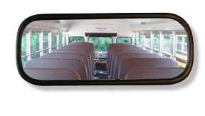
RAILROAD CROSSINGS

Drivers are responsible for the safe crossing at all railroad crossings. All approved school buses are required to stop at all railroad crossings. Drivers will complete the following procedure at railroad crossings:

1. Activate the four-way hazard lights at least 150 feet from the railroad crossings.
2. Move as far to the right of the road as practical.
3. Turn off master switch.
4. Stop the bus completely at least 15 feet, but no more than 50 feet, from the nearest rail.
5. Shut off noisy equipment and instruct passengers to be quiet while listening for approaching trains.
6. Open the service entrance door and the driver’s window to look in both directions and listen for approaching trains.
7. Drivers shall, in every instance, cross in a gear that will not necessitate changing gears while traveling across tracks.
8. After the rear of the bus has cleared the track, turn off the four-way hazard lights and turn the master switch on.

A school bus stopped at any railroad crossing where there are flashing red lights and/or bells in operation, shall not proceed across such tracks unless by authorization from law enforcement officer or train personnel or the lights stop flashing. This does not relieve the driver of personal responsibility for safe crossing. No driver shall drive the bus through, around or under any crossing gate or barrier at a railroad crossing while the gate or barrier is closed or being opened or closed. The driver must never accept a lack of movement as indicating that the device is either in or out of order or not properly operating, but must always take a railroad grade crossing as a warning of danger and must not cross the tracks until it has been conclusively ascertained that no train(s) is approaching.

WHEN STOPS AT RAILROAD CROSSINGS ARE NOT REQUIRED

- At railroad crossings that are posted EXEMPT by order of the commissioner of transportation.
- At any such crossing when a police officer or a traffic control signal directs traffic to proceed.

ALL school bus drivers shall be instructed on any special characteristics of railroad grade crossings on routes to be driven.

EMERGENCY EVACUATION DRILLS

As most students ride a bus to and from school or on activity trips, it is essential that all be taught emergency evacuation procedures. In a crisis situation, students who have been properly trained in how to evacuate a school bus will do so in a timely and orderly fashion. Evacuation drills shall be conducted each school semester.

ASSESS THE NEED TO EVACUATE

Student safety and control is best maintained by keeping students on the bus during an emergency and/or impending crisis situation if doing so does NOT expose them to unnecessary risk or injury. A decision to evacuate should include consideration of the following situations.

1. Is there a fire?
2. Is there a smell of leaking fuel?
3. Does the possibility exist that the bus will roll/tip causing further threat to safety?
4. Is the bus likely to be hit by another vehicle?
5. Is the bus in the direct path of a natural disaster such as rising water?
6. Is the bus in the path of an approaching train?
7. Would evacuating students expose them to speeding traffic, severe weather, or a dangerous environment? The bus should be visible a minimum of 300 feet in each direction. A position over a hill or around a curve where such visibility does not exist should be considered reason for evacuation.
8. Considering the medical, physical, and emotional condition of the students, does staying on the bus or evacuating pose the greater danger to student safety?
9. Any other condition which may dictate evacuation.

EVACUATION RESPONSIBILITIES

The bus driver is responsible for the safety of the pupils. Written evacuation instructions and emergency telephone numbers should be posted in the bus. If help must be summoned from a near-by residence, always send 2 responsible students. Students who are appointed to assist in evacuation drills should be trained in the event the driver is incapacitated. In selecting these students, consideration should be given to maturity, good citizenship, and they should live near the end of the bus route. These students should know how to:

1. Set emergency brake & turn on four-way flashers
2. Turn off ignition switch/shut down engine
3. Summon help when and where needed
4. Use all emergency egress exits
5. Set warning devices
6. Open & close doors and account for all students
7. Help small students off
8. Use radio to summon help if so equipped

TYPES OF EVACUATION DRILLS

Drills should be restricted to school property and conducted under the supervision of school officials. Below are evacuation plans students should know:

1. Rear emergency door evacuation.
2. Front door (service door) exit.
3. Side door evacuation.
4. Front and side/rear door evacuation. Passengers in the front half evacuates from the service door and passengers in the rear half from the side/rear door.
5. Students should be familiar with the operation of emergency windows and roof hatches.

During drills students should be given the opportunity to open these exits to ensure their ability to operate these devices. All students, unless excused for cause, should participate in several planned evacuation drills each year. It is the school district’s responsibility to determine which students will be exempt from an evacuation drill on the basis of being excused for cause. Excused for cause means that there exists a valid concern for the safety and wellbeing of the student who will be exempt from participation in any school bus emergency evacuation drill. The following is a non-inclusive list of examples of conditions which may be a valid cause for exemption.

1. Wheelchair bound student with positioning rods and braces.
2. Medically involved student with intravenous or catheter.
3. Physically injured student with splints, braces or crutches.
4. Students with severe sensory loss who may become confused or disoriented.
5. Students with severe emotional sensitivity who may become unmanageable.

If you are involved in an accident:

1. Remain calm.
2. Assess the situation with a clear mind.
3. Without delay, write down all the necessary information

In an accident - Observe the following procedures:

- Stop the vehicle immediately, no matter how trivial or unimportant the accident may seem.
- Do not move the vehicle unless authorized to do so, or unless its location may result in further danger.
- Set parking brake, activate four-way flashers, and turn off engine. If driver must exit bus, remove the keys.
- Evaluate the accident scene to determine if the vehicle needs to be evacuated. If bus is evacuated, make certain all passengers are in a safe place.
- Check for injuries. If there are severely injured passengers, make them comfortable, but do not move them unless it is absolutely necessary.
- Notify local authority and provide the location of the accident and if there are any injuries.
- Protect the scene, set out emergency triangular reflectors.
- When another vehicle is involved, obtain driver’s name, license number and state of issue, insurance company name and a list of passengers.
- Obtain names of all passengers on board and make notation of each passenger’s seating location.
- If there are witnesses, get their name, address and telephone number.
- Remain at the scene of the accident until a law enforcement officer tells you to proceed.
- Do not release students to anyone without proper authorization, i.e., law enforcement, superintendent, or his/her designee.
- In making any statements, be accurate and factual.
a. Make no admission of fault
b. Make no accusations
c. Do not discuss accident with anyone other than a law enforcement officer, St. Mary's First Nation Education Director or School Superintendent or his/her designee.

Gather all the necessary information needed to file an accident report before leaving the scene. Information relative to the accident is prepared after your responsibilities to the passengers has ended or has been taken over by an appropriate person. As soon as possible, sit down and prepare a diagram of the accident scene. Describe in detail how the accident occurred. Explain what you actually observed. Details like weather, road condition, time of day, and the actions of other driver(s) should be included.

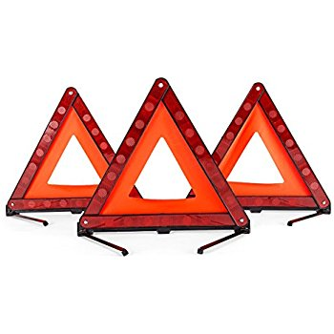

EMERGENCY DRIVING SITUATIONS

As a school bus driver, you will experience a variety of emergency driving situations. You will be able to handle emergencies more successfully if you know how to deal with some of them in advance.

CURVES

When you approach a curve, your speed, the contour of the curve and your load will affect the control. Slow down before the curve and once into the curve, accelerate slightly. Never attempt to pass a vehicle when approaching a curve.

TIRE BLOWOUT

Good maintenance can prevent a tire from blowing. A tire blowout occurs when air pressure is lost or the tire hits an object on the roadway. Do not brake.

When this occurs to a front tire, the vehicle will swerve to the side of the blowout. It can be especially dangerous if the left front tire blows out. The vehicle will swerve into oncoming traffic. When this happens, you must steer firmly against the pull of the vehicle to keep it on its intended path. Take your foot off the accelerator.

If the rear tires blow, the vehicle might fishtail. Grip the steering wheel firmly and ease off the accelerator. Do not brake. Steer straight ahead until you have control. Turn on your emergency flashers. Once you have control, try pulling your vehicle off to the side of the road.

BRAKE FAILURE

If your brakes fail, down shift to a lower gear, pump brake pedal, look for an escape route while slowing down and steer your vehicle off the roadway. On some vehicles, use of the parking brake may help. Once you are off the roadway set the parking brake and wheel chocks. Do not move bus until repairs are completed.

ACCELERATOR LOCK

If the accelerator sticks, pump accelerator pedal with several hard jabs, apply the brakes, activate four way flashers, and choose an escape path that leads to a safe place off the roadway and continue braking. Shift to neutral or depress the clutch. Steer to the escape route and turn off the ignition.

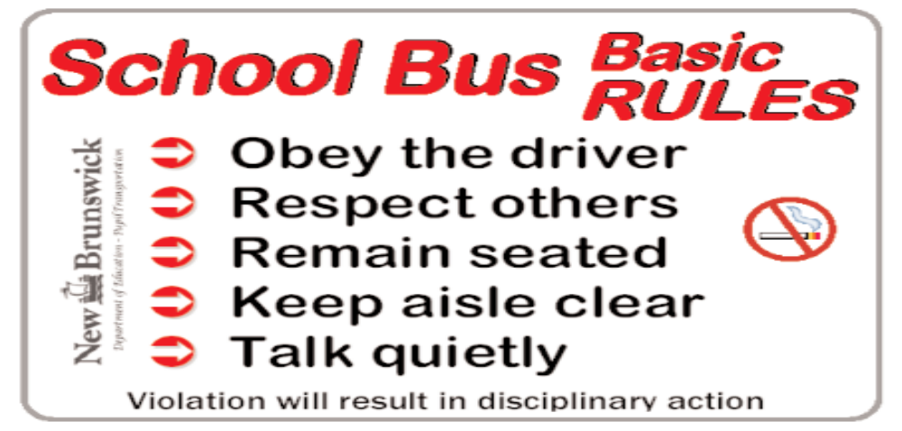

Community Tips (You and I)

- Slow Down
- Be especially careful when driving in our community streets and around school zones,
- The speed limit within school zones in 30km/hr
- Be alert for youngsters walking to and from school as you back out of your driveway.
- Stop your car when you see lights flashing on a school bus. Red flashing lights indicate that the bus is stopped and students are getting on or off. Don’t start driving until the red lights stop flashing. Be aware that a child may dash across the street.

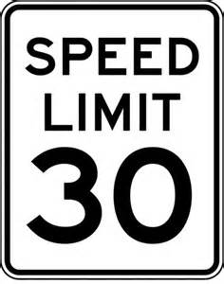

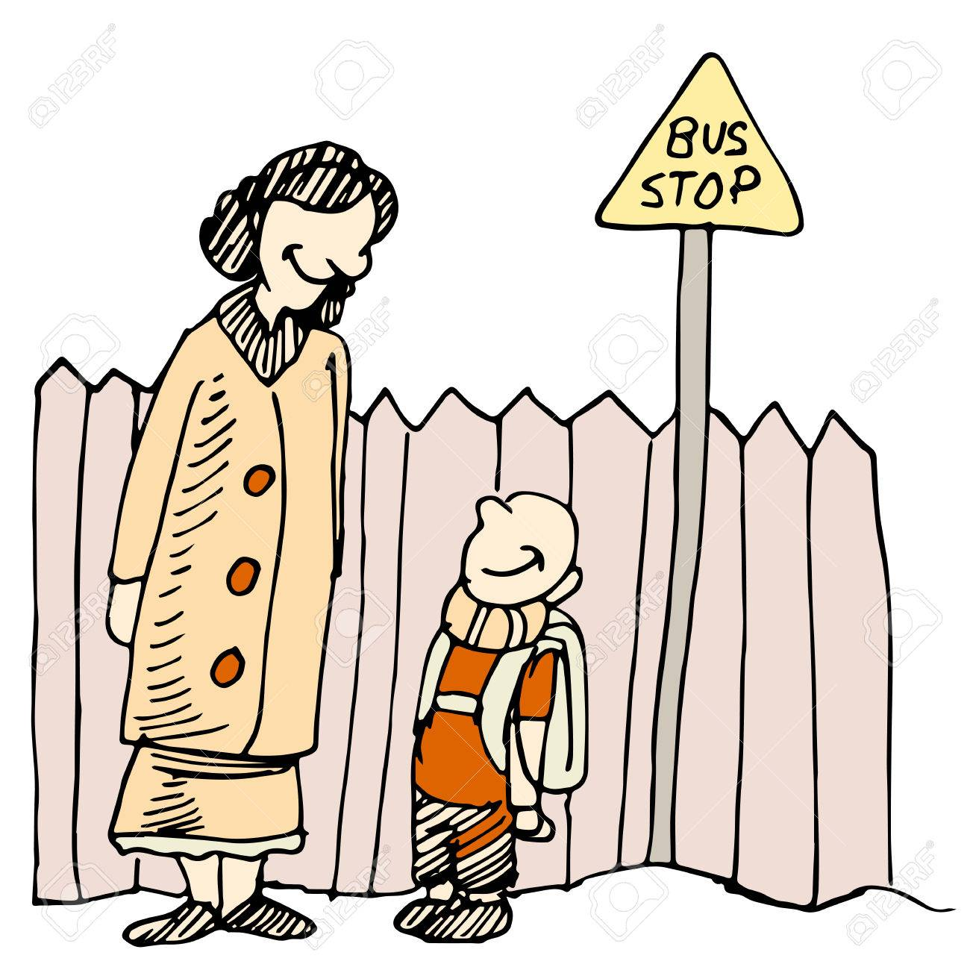

BUS CLEANLINESS
As a bus driver, you have a lot on your plate: transporting lots of children to and from on school daily basis and transporting them on various field trips. In completing this task, it is very important to keep the bus clean. Cleaning the bus should be completed on a daily basis. Here are a few ideas to maintain a clean, sanitized, and tidy!
Interior
- Sweep out the bus at the end of your route every day. This will ensure that the dirt doesn't linger.
- Hose out the interior of your bus at least once a month. Don't forget to spray the roof and the windows, too!
- The driver's area of a school bus tends to collect dirt so vacuum or wipe off your seat and dash.
- Sanitize seats once a week. Kids carry germs, and can be spread easily. Don't forget the sides and backs, too!
- If you have gum or other sticky debris on your seats, scrape it off with a razor blade.
- Wipe off all of your rear view mirrors (interior and exterior).
- If your floors need some extra attention, mix some floor cleaner with water in a bucket. Mop it until it shines!

Exterior
- Wash the outside of your bus once a month (or as needed). You'll likely need a ladder, but make sure you pay attention to the top of the bus as well! Please exercise caution.



In addition to radio announcements, the school district will place a recorded message at 453-5455, no later than 6:30 am and place on the Anglophone West website at (http://web1.nbed.nb.ca/sites/asd-w/Pages/default.aspx.) to inform the public of school closures because of inclement weather. Closures are typically posted on social media sites. Please feel free to use either of these services.

Taken from New Brunswick DEPARTMENT OF EDUCATION AND EARLY CHILDHOOD DEVELOPMENT Policy 504 Appendix A http://www2.gnb.ca/content/dam/gnb/Departments/ed/pdf/K12/policies-politiques/e/504AA.pdf

